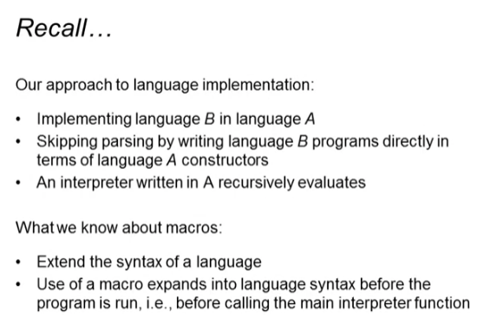

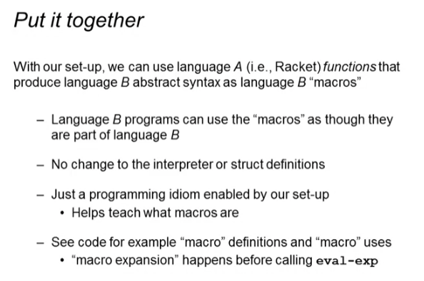

* This is like syntactic sugars

andalso Function

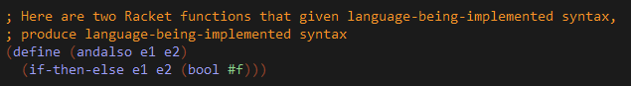



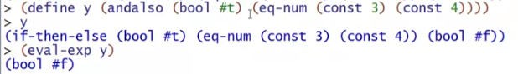

double Function



list-product Function

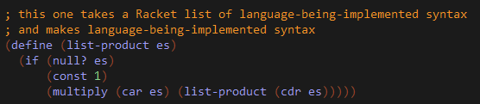

test Function

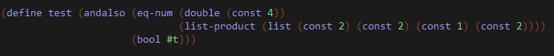

* Never evaluate expressions in our Racket functions macro. eval-exp should be the one responsible in evaluating expressions!

